Name: Period: Date:
Photojournalism
Rule of Thirds
- Every pictures must have a focal point (one picture or person that is the main focus of the frame); the focal point should instead be off center as determined by dividing the picture into thirds

- In the picture above, divide the frame into thirds both vertically and horizontally. Where ever the lines cross is where a focal point should be. They are marked with stars.
- This keeps the picture visually interesting and exciting
- Our goals:
  - Use the rule of thirds when placing a focal point in a frame
Contrast
- Contrast is the spectrum of tones in the pictures from light to dark
- If a picture doesn’t have a lot of color variety it is low contrast
- A picture that has a wide variety of color from light to dark is said to have high contrast
- Our goals:
  - Pictures with high contrast
  - Pictures that have light and dark tones in one frame
Candid
- Candid pictures are the opposite of posed pictures; they are taken mid-action when the subjects do not know you are capturing them
- They are preferred for photojournalism because they capture real emotion and natural action
- Our goals:
  - Pictures that are candid instead of posed
Tips to Remember:
- Check to make sure the batteries are charged, a memory card is in, and the lens cap is off before taking any photos
- Keep the focus on “auto” (the green option) at all times
- Stand at least 2 feet from all subjects to ensure a clear shot
- Be creative with angles! Shoot from above, below, around corners, or even laying on the floor!
Answer the following questions with your partner to assess the photographs below. You do not need to write in complete sentences.
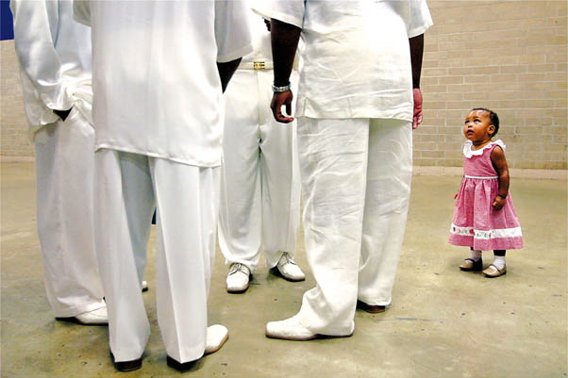
(1) What is the focal point of the picture? ________________________________________________________
(2) How does the focal point of the picture stand out? ____________________________________________
(3) Does the picture use rule of thirds? ____________________________________________________________
(4) Is the picture candid? ________________________________________________________________________
(5) Does the picture have high or low contrast? ___________________________________________________
(6) Would this picture be used in a yearbook or newspaper? _______________________________________
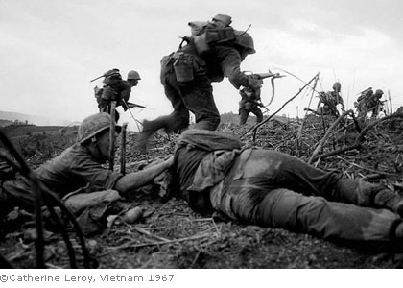
(7) What is the focal point of the picture? ________________________________________________________
(8) How does the focal point of the picture stand out? ____________________________________________
(9) Does the picture use rule of thirds? ____________________________________________________________
(10) Is the picture candid? _______________________________________________________________________
(11) Does the picture have high or low contrast? __________________________________________________
(12) Would this picture be used in a yearbook or newspaper? ______________________________________
(13) Which of these pictures do you prefer? Why? _________________________________________________
____________________________________________________________________________________________________________________________________________________________________________________________________

