Perspective
- The point of view of a message’s creator
- Examples: Diet Dr. Pepper is just like Dr. Pepper, Tide is better than Cheer, Kit Kats are great for a break
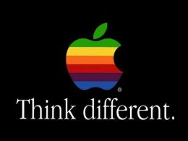

Audience
- The people who are reached by a publication
- Examples: A class reading a book, subway riders passing a billboard, teenagers viewing commercials during “Secret Life”

Purpose
- The reason something exists
- In publications, either to inform, persuade, or entertain
- Examples: advertisements persuade consumers to buy, books entertain readers, the news informs its viewers

