Four Persuasive Techniques
(1) Bandwagon
• Creating the illusion that the majority is using a product or feels a certain way
• Examples: “Everyone is doing it!”, “America runs on Dunkin’”

(2) Celebrity Testimonial
• Having a popular athlete, actor, or public figure endorse a product to make it seem more desirable
• Examples: Beyonce for Emporia Diamonds, Michael Jordan for Nike
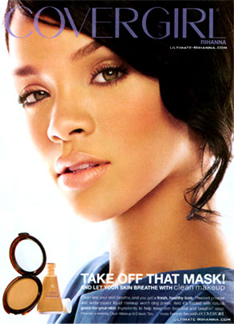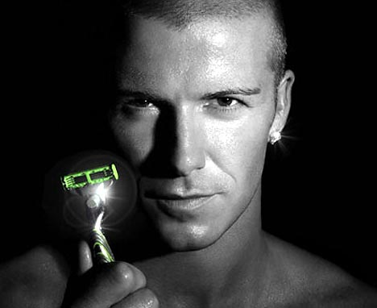

(3) Emotional Appeal
• Using fear, sympathy, or anger to motivate a consumer
• Example: creating a false sense of danger to sell insurance, showing pictures of starving children to raise money
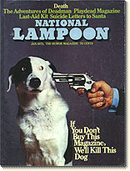

(4) Association
• Creating the illusion that a product can create desirable effects
• Example: clothes make you pretty, body spray makes you popular, food makes you thin
